CHEM106: Assignment 8

Hydrogen Atom

1. For the hydrogen-like atoms, the solution of the Schrödinger equation leads to the quantized energy .

A. Calculate the energy (in eV) for the hydrogen atom at various values of n, and plot the energy levels.

For the hydrogen atom, z = 1, and , and the Rydberg constant RH is defined as



Given that , we have



Thus, .

|  |  |
| --- | --- |
| n | En(eV) |
| 1 | –13.59 |
| 2 | –3.40 |
| 3 | –1.51 |
| 4 | –0.85 |
| 5 | –0.54 |
| ∞ | 0 |

The energy levels can be plotted as follows

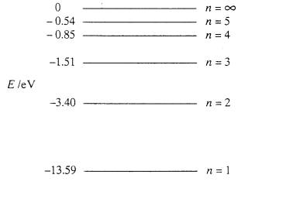

B. Calculate the absorption frequency in wavenumbers (cm–1) for an electron in the hydrogen atom undergoing a transition from the n = 2 level to the n = 5 level.

Look up the energy table in part A. We have

.

Since ,

we have .

To express the frequency in wavenumber, we need to divide the frequency by the speed of light



C. Determine the ionization energy (in eV) for the hydrogen atom.

As the hydrogen atom ionizes, the electron moves from the n = 1 state (ground state) to n = ∞ state. Look up the energy table in part A. We have

.

2. The solution of the Schrödinger equation for the hydrogen atom produces three quantum numbers n, l, and ml.

1. Name the three quantum numbers, and describe how they are related.

The three quantum numbers n, l, and ml are named principal quantum number, angular momentum quantum, and magnetic quantum number, respectively.

For a given n, .

And for a given l, .

1. For the n = 3 energy level of the hydrogen atom, what are the allowed quantum states?

The allowed quantum states are characterized by the three quantum numbers n, l, ml.

For n = 3, the possible combinations (n, l, ml) are (3, 2, –2), (3, 2, –1),

(3, 2, 0), (3, 2, 1), (3, 2, 2), (3, 1, –1), (3, 1, 0), (3, 1, 1), and (3, 0, 0).

1. For the n = 3 energy level of the hydrogen atom, what is the degeneracy?

For the hydrogen atom, energy is only dependent on the principal quantum number. For the n = 3 energy level, as shown in part B above, there are nine possible states. Thus, the degeneracy is 9. In general, the degeneracy for the nth energy level is n2.

3. The solution of the Schrödinger equation for the hydrogen atom results in the wavefunction for the 1s state .

1. Calculate the probability of finding the electron within a distance of 3a0 from the nucleus.

The probability for finding the electron is given by



Let z = r / a0, we have





Here, a mathematical technique of integration by parts, is adopted.

1. Is there a node in the wavefunction for the 1s orbital?

A node is a point, plane or surface at which the wavefunction is zero, and changes sign before and after. The only possibility for the wave function  to be zero is when r approaches infinite. Thus, there is no node in the 1s orbital.

4. What is the meaning of the atomic term symbol 3F?

The electronic states of a multi-electron atom can be characterized by the term symbol 2S+1L, where L and S are total angular momentum and total spin quantum number, respectively. The term symbol 3F means that L = 3 and S = 1.